COSTED IMPLEMENTATION PLAN (CIP) ON PAS-PROJECT ISSUE AREAS, 2019 – 2020
Background
The cost implementation plan (CIPs) is a specific plan for achieving the goals of each of the area over a specific period. It highlights the program activities necessary to meet state goals; and detail the costs associated with the activities, providing clear program-level information on the resources a state must raise domestically and from partners. Plans serve as the implementation roadmap, resource mobilization, performance monitoring, advocacy, planning & management, and cost implementation plans for each of the issues area. It is prepared with the support from partners and CSOs to make the government more organized, focused, result-driven leading and assuming greater ownership of the response on each of the issue areas.
Therefore, each of the PAS-project issue areas; PHCOUOR, IMCI- CKD, Family planning and Routing immunization have their specific CIPs that guide their operational activities yearly. These activities are divided into thematic areas of focus for simplicity. For instance, the FP is divided into six thematic areas with various activities and budget aims at driving the FP for the year. The RI also has five thematic areas of focus, designated activities and allocated budget. However, each of the activity in the thematic areas is linked to the overall goals and objectives each state aims to achieve on the specific issue area.
Cost Implementation Plans by States and PAS-Project Issue Areas
A. Routine Immunization
- Kano State Routine Immunization Operational Plan for 2019
- Kaduna State Routine Immunization (RI) Plan, Jan-Dec 2020
B. Family Planning
- Kano State Costed Implementation Plan for Child Birth Spacing, 2018–2020
- Niger State Costed Implementation Plan for Family Planning, 2017-2020
- Lagos state Family Planning Costed Implementation Plan 2019-2023

Table 1: Annual Costed Plan for the RI and FP, 2019 and 2020
COSTED IMPLEMENTATION PLAN FOR PAS-STATES ON RI & FP

States | Routine Immunization |  | Family Planning
 | 2019 | 2020 | 2019 | 2020
Kaduna | n.a | 543,719,582 | n.a | n.a
Kano | 418,892,380 | n.a | 1,187,718,568 | 1,777,573,262
Lagos | n.a | n.a | 1,970,000,000 | 1,570,000,000
Niger | n.a | n.a | 1,364,591,732 | 1,507,688,704
Source: Computed from Niger State, Kaduna, Lagos, Kano States RI and FP CIPs

The table above shows the cost implementation plan for the routine immunization and the family planning in each of the Four PAS-project states namely; Kaduna, Kano, Lagos, and the Niger States. It could be deduced that in 2019 only Kano state Cost Implementation Plan for RI is available while the three other states were not available. Similarly, only Kaduna state has Costed implementation plan for RI in 2020. The other three states were not available. More so, the 2019 and 2020 cost implementation plans are available in both available in three states namely; Kano, Lagos, Niger except Kaduna. The unavailability of the Cost Implementation Plan in some of the issue areas raised a question of how to achieve the goals of the RI and family planning in the states. It also raised some questions about the efforts of the CSOSs and professionals working in the issue areas to lay their voice and come to the table with the government with aim the of drawing out the plan.
However, fig 1 below shows the amount each state proposed to spend on Family Planning in the state in billion. Lagos State has the highest amount figure for its FP in 2019. It envisaged a 20% decrease in 2020. The Kano State proposed to increase the spending by 49.6% in 2020, likely wise Niger State with a 10% increase. Meeting this target depends on the amount released for the CIPs execution in 2019 and the amount to be released in 2020. The point is that no significant progress would be made unless and until the states combined this commitment with releases. The monitoring and supervision team within and outside the government must also ensure that the releases are monitor to ensure that they are used for the purpose in which they are released.
Fig 1: Annual costed Plan for FP, 2019 and 2020
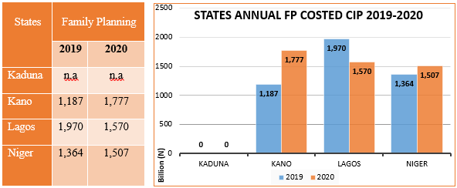Source: Computed from Niger, Kaduna, Lagos, Kano States RI and FP CIPs

CIPs by Thematic Areas on Issue Areas
Each of the issues areas have their specific thematic areas covering various strategic priority. For instance, RI has about five thematic areas as can be seen in fig 2 and 5. However, the level of commitment each of the thematic areas varies. According to the fig 2, in Kano State, service delivery took the largest proportion of resources 53.2% of the total 2019 cost implementation plan, followed by demand creation 26.8%. The lowest resource needs are in policy and enabling environment, and financing which stood at 0.5%. Whereas in Niger State, demand creation required the largest proportion of resources with 31.8% of the total 2019 costed implantation plan, follows by services delivery 25% and the lowest resources needed was financing with 1.3%. The priority of each state is based on the peculiarity of their problem on the issues area.
Fig 2: States FP Plan Total Costs Per Thematic Areas 2019

Source: Computed from Niger, Kaduna, Lagos, Kano States RI and FP CIPs

Fig 3 below shows Niger State requires N470 Million for demand creation in its 2020 FP costed implementation plan. This represents 31.1% of the total costed plan. This is followed by service delivery with 25.6%. Whereas financing requires the least resources 1.3% of the total costed implementation plan to drive the FP activities in the Year 2020. In Kano State, service delivery with 50.6 % requires the highest resources in 2020 FP costed implementation Plan, follow by demand creation with 29.8%. The policy environment requires the least funding of 0.2% of the total costed implementation plan in year 2020.

Fig 3: States FP Total Costs Per Thematic Areas 2020
Source: Computed from Niger, and Kano States FP CIPs

The 2019 RI Implementation plan in Kano State shows that more attention is paid to the vaccine security, cold chain, and logistics which consume about 47. 3% of the total 2019 State RI plan. The least require resources are for leadership and governance/ financial management. Although the source of RI plan funding for the line items was not stated in the plan, about N418,764,006 representing 99.9%. was released at the end of the year out of the total N418,892,380 costed plan. This release is an indication of the State’s strong will and commitment towards achieving 85% routine immunization coverage in every ward of Kano State in 2019. We encourage the state to sustain this effort to be able to reduce infant and under 5 years old mortality rate. And in essence lift Kano State out of the red line giving the state highest numbers of unimmunized children in the state (NSIPSS, 2018-2028).
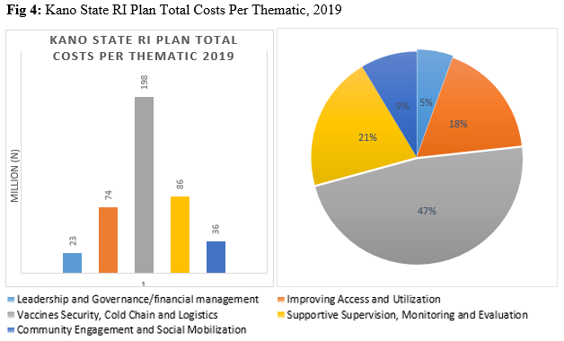
Source: Computed from Niger, Kaduna, Lagos, Kano States RI CIPs

Fig 5 also shows that 51% of 543719,583 RI cost implementation plan will be spent on vaccine security, cold chain, and logistics, while the community engagement and social mobilization which represent 1% of the total amount have the least priority in 2020. The other three thematic areas will utilize the remaining fund when made available. The state immunization coverage level was below average. Similarly, the state also has more unimmunized children in the country. Thus, the state must ensure; effective implementation of partnership framework in RI services; and eliminate delays in funding delivery through State RI basket funds and increase funding for RI in all LGAs. These will go a long way to improve the level of childhood survival in the state and achieve the desired program objectives.
Fig 5: Kaduna State RI Plan Total Costs Per Thematic Areas, 2020
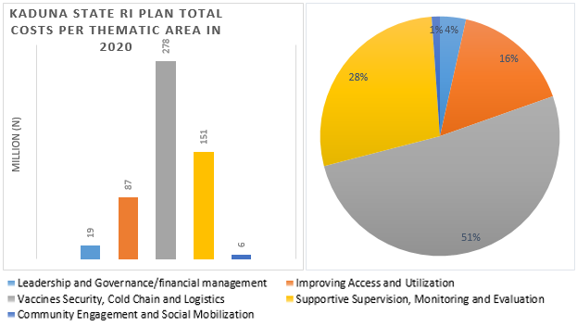
Source: Computed from Niger, Kaduna, Lagos, Kano States RI CIPs

PAS-Project Issue Areas and CIPs Development Partners
Each of the implementation plans is prepared by the state government with support from the donors and numerous partners through Technical Working Groups (THG) specialized in each of the issue area (RI, FP, PHCOUR & IMCI-CKD) and provides valuable input to the draft documents. Table 2 below contains the list of the TWG group who help in developing the Costed implementation plans for each state.

Table 2: TWG Responsible for Developing Issue Areas in Each state
States | RI | FP | PHCOUR | IMCI –CKD
Kaduna | SERICC | Technical Working Group (TWG) for Family Planning | PHC Task Force Team | PHC Task Force Team
Kano | SERICC | RH/FP Technical working group | PHC team | RMNACH/Nutrition
Lagos | RI Technical Working Group | Child Spacing Advocacy Working Group (CS-AWG) | PHC team | NSAC-CKD
Niger | SERICC | State Task Team for Family Planning, | PHC team | OGP Niger

Observations
- Most of the states do not link their FP and RI costed implantation plans to their annual budget. It will be very difficult for independent observers to track and monitor the spending. This could bread corruption.
- There is no RI costed implementation plan for the year 2019 for most of the states. This will make it difficult to assess how the government prioritizes issues around routine immunization in the PAS project states and effort towards addressing them.
- Most of the activities in FP are donor-driven. Development partners shoulder a large portion of the burden. Although, some non-governmental organizations (NGOs) support the state in capacity building, advocacy, and supportive supervision.
- Most states (Niger, Lagos, and Kano) have not produced their 2020 RI costed implementation plan when the first quarter almost gone. This shows their level of commitment on the issues of RI and FP.
- The current Kano and Niger States FP implementation cost plan will end by December this year.

Recommendations
- There is a need to carry out a financial gap analysis to establish the nature of the funding available both from the government and the development partners to ensure continued support for the implementation of this plan.
- We encourage the state government to tie their RI ad FP funding to the state annual budget for transparency and accountability.
- The state should begin to work towards taking ownership of the RI and FP projects in their states by identifying other possible internal sources of funding.
- The state should work and produce their 2020 RI (in the case of Niger, Lagos, and Kano) and FP (in the case of Kaduna) implementation plan as soon as possible.
- The government and the various stakeholders in Kano and Niger States working on FP should begin to roll out the process for the new draft, taking into consideration the strength and challenges in the current plan for efficiency. Failure to act before the end of the year may delay full implementation next year.

Sources

- Kaduna State Routine Immunization (RI) Plan, Jan-Dec 2020
- Kano State Appropriation Law 2019
- Kano State Costed Implementation Plan for Child Birth Spacing, 2018–2020
- Kano State Routine Immunization Operational Plan for 2019
- Lagos state Family Planning Costed Implementation Plan 2019-2023
- Multiple Indicator Cluster Survey (MICS5)-National Immunization Coverage Survey (NICS) 2016-17; Study Documentation
- Niger State Costed Implementation Plan for Family Planning, 2017-2020
- Nigeria Strategy for Immunization and PHC System strengthening (NSIPSS) 2018-2028.
- Kano State RI Costed Implementation Plan Actual Releases & Utilized for the year 2019, was Retrieved from the State Primary Health Care Development Agency (SPHCDA), Kano State.

