NATIONAL AND STATE GOVERNMENTS COMMITMENT ON FAMILY PLANNING, 2019 AND Q1 2020
FACT SHEET

Context
One of the three commitments made by the federal government in 2017 is to ensure sustainable financing for the National Family Planning Program. As result, the Federal Ministry of Health (FMoH) in the year obtained approval from the Federal Executive Council to renew the Memorandum of Understanding with UNFPA to ensure the provision of US$4million (N1.2Billion) annually from 2017 to 2020 for procurement of contraceptives for the public sector (an increase from the US$3 million committed from 2011 to 2014). Three years down the line, has Nigeria meets up to this commitment? This fact sheet tends to ascertain the whether or not the government has realized its FP financial commitment in 2019 and Q1 2020.

Federal Government FP Budget Commitment, 2019 and 2020
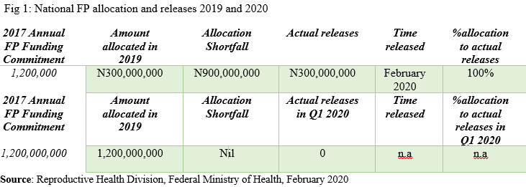
Family planning financing has been a major issue in Nigeria despite the government series of commitments in the past years. In 2019 fiscal year, N300,000,000 was allocated. This is 25% of the total commitment made in 2017. This is far below average. As such the fund was not released for the family planning programs in the year until February 2020, two months after the end of 2019 fiscal year. Although the amount was released in full, the time it was released does not allow the government to achieve its family planning target in the year. There is a shortfall of N900,000,000.
However, a total of N1,200,000,000 was allocated for FP in the 2020 Appropriation Act for procurement and distribution of family planning commodities through counterpart funding to UNFP. At the time of writing this report, no single Naira has been released for the first quarter of the year. Probably, the government may not release money for the year soonest giving the recent release of funds for the 2019 allocation. By implication, the government has just started executing the FP program slated for the year 2019 in 2020.

Family Planning Budget Performance in the PAS-States, 2019-2020
The FP budget performance in the PAS-State has not been encouraging. Apart from poor allocation on FP, there is also poor release. In Kaduna state, the FP budget allocation for the year 2019 is N27,644,200. Thus, N1,400,000 representing 5 percent of the total FP approved budget for the year was released. In Kano state N182 million was budgeted but no release was made. Lagos state made a giant stride with the allocation of N189 million for FP but only N89 million which represents 46.7% of the total allocation as at the end of December 2019 was released. In Niger State, N8million naira was allocated in the 2019 budget for FP and N5 million was released. The 2019 FP budget performance in Niger was just 66.1 percent despite the paucity of the allocation.

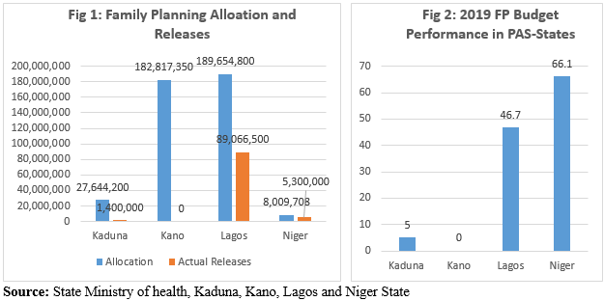

Table 1 below shows the Family budget allocations in the four PAS-State in the 2020 fiscal year. About N293,615,857 is allocated for the FP in Lagos states for the 2020 year. This shows a 54.8% increase from the 2019 FP budget allocation. As of March 2020, no amount has been released to carry out FP activities in the Q1 of the year. In Kaduna State, N12,250,000 is allocated for the FP in 2020, which represents about 55.6% decrease from 2019. This is an indication of the government’s low commitment to the issue of FP. Kano has no allocation and releases for the FP in 2020.

However, Niger State budgeted for the FP in the 2020 but this is made in a lump sum with other programs and activities. About 100,000,000 was budgeted for primary Health Care Programs: Nutrition, Safe Mother wood, Family Planning, Adolescent Health, Women in Health, Immunization, MNCH Week, DRF, Environmental Health, IMCI, Health Promotion, CHIPS, CORPS, Monitoring and Evaluation Activities. The budget did not specify how much is meant for the FP and the efforts to get this information from the states PHC has not been successful.

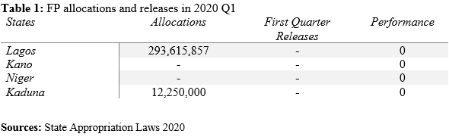
Conclusion
Giving the above funding commitment, there is no doubt government has not realized its FP funding commitment. This is due to poor allocation and releases. It also likely, that government may not achieve much before the end of the year. Concerning the PAS-states, their efforts towards FP is also very not encouraging and need proper attention.
Recommendations
There is a need to improve budget oversight, more collaborations with state actors, full releases and cashback for all FP appropriated funds, as well as the alternative and complementary means of funding both at the national and in each of the PAS-State for the FP programs and activities.
References
- Family Planning 2020 Commitment: Government of Nigeria. Available at http://www.familyplanning2020.org/nigeria
- Kaduna State Appropriation Law 2019
- Kaduna State Appropriation Law 2020
- Kaduna State FP Allocations and Releases & Utilized for the year 2019, was retrieved from the State Primary Health Care Development Agency (SPHCDA), Niger State.
- Kano State Appropriation Law 2019
- Kano State FP Allocations and Releases & Utilized for the year 2019, was Retrieved from the State Primary Health Care Development Agency (SPHCDA), Kano State.
- Lagos State Appropriation Law 2019
- Lagos State Appropriation Law 2020
- Lagos State FP Allocations and Releases & Utilized for the year 2019, was retrieved from the State Primary Health Care Development Agency (SPHCDA), Lagos State.
- Niger State Appropriation Law 2019
- Niger State FP Allocations and Releases & Utilized for the year 2019, was retrieved from the State Primary Health Care Development Agency (SPHCDA), Niger State.

